Assignment05

- Assume that the waiting time x for an elevator is uniformly distributed between zero and six minutes.

a. Write the formula for the probability curve of x.

b. Graph the probability curve of x.

c. Find P (2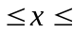4)

d. Find P (36)

e. Find P ({02} or {56}).
Solution:
a. for 0 ≤ x ≤ 6.
= 0 otherwise
b. f(x)
1/6
0 6 min
c.
d.
e.

2. Refer to Exercise 1

a. Calculate the mean, 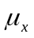.the variance, 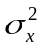, and the standard deviation, 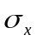.

b. Find the probability that the waiting time of a randomly selected patron will be within one standard deviation of the mean.
Solution:
a.
b.
- Consider the figure given in the margin. Find the value k that makes the function f(x) a valid continuous probability distribution.
f(x)
0
5
x
k
Solution:
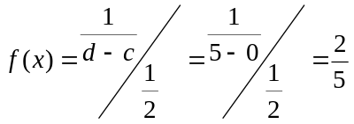

4. Suppose that the random variable z has a standard normal distribution. Sketch each of the following z points, and use the normal table to find each z point.

a. 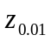 b.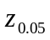 c.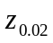 d.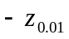 e. 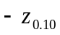
Solution:
a.
b.
c.
d.
e.
f.
5. Stanford-Binet IQ Test scores are normally distributed with a mean score of 100 and a standard deviation of 16.

a. Sketch the distribution of Stanford-Binet IQ test scores.

b. Write the equation that gives the z score corresponding to a Stanford-Binet IQ test score. Sketch the distribution of such z scores.

c. Find the probability that a randomly selected person has an IQ test score

(1) Over 140.

(2) Under 88.

(3) Between 72 and 128.

(4) Within 1.5 standard deviations of the mean.

d. Suppose you take the Stanford-Binet IQ Test and receive a score of 136. What percentage of people would receive a score higher than yours?
Solution:
a.
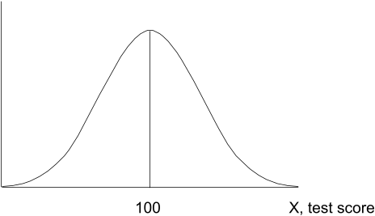

b.
c. (1) P(x > 140) = P(z > 2.5) = 1 – .9938 = .0062
(2) P(x < 88) = P(z < –.75) = .2266
(3) P(72 < x < 128) = P(–1.75 < z < 1.75) = .9599 – .0401= .9198
(4) P(–1.5 ≤ z ≤ 1.5) = .9332 – .0668 = .8664

d. P(x > 136) = P(z > 2.25) = 1 – .9878 = .0122; 1.22%

